12. ReactJS-HOL
Creating React App : npx create-react-app ticketbookingapp
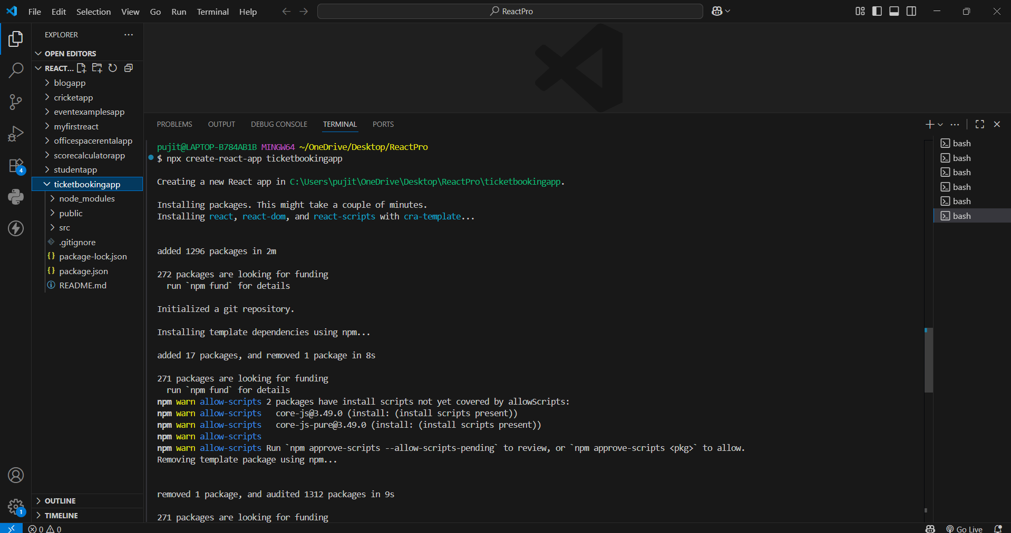

App.js :
import React, { useState } from 'react';

// 1. Child greeting components
function UserGreeting() {
return <h1>Welcome back</h1>;
}

function GuestGreeting() {
return <h1>Please sign up.</h1>;
}

// 2. Greeting component using conditional rendering
function Greeting(props) {
const isLoggedIn = props.isLoggedIn;
if (isLoggedIn) {
return <UserGreeting />;
}
return <GuestGreeting />;
}

// 3. Button components
function LoginButton(props) {
return <button onClick={props.onClick}>Login</button>;
}

function LogoutButton(props) {
return <button onClick={props.onClick}>Logout</button>;
}

// 4. Main App component handling state & element variables
export default function App() {
const [isLoggedIn, setIsLoggedIn] = useState(false);

const handleLoginClick = () => {
setIsLoggedIn(true);
};

const handleLogoutClick = () => {
setIsLoggedIn(false);
};

// Element Variable pattern for conditional rendering
let button;
if (isLoggedIn) {
button = <LogoutButton onClick={handleLogoutClick} />;
} else {
button = <LoginButton onClick={handleLoginClick} />;
}

return (
<div style={{ padding: '50px', fontFamily: 'sans-serif' }}>
<Greeting isLoggedIn={isLoggedIn} />
{button}
</div>
);
}
Running on localhost 3000 :
